Isaiah Bryant

CS 255 System Design Document

UML Diagrams

UML Use Case Diagram
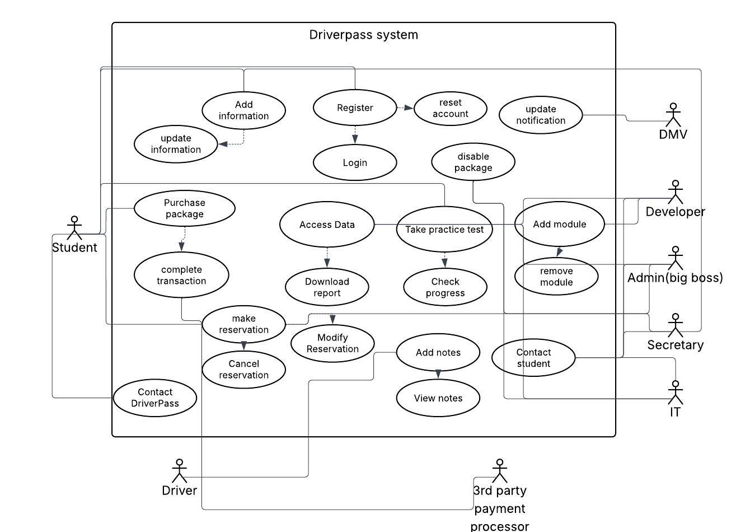
UML Activity Diagrams
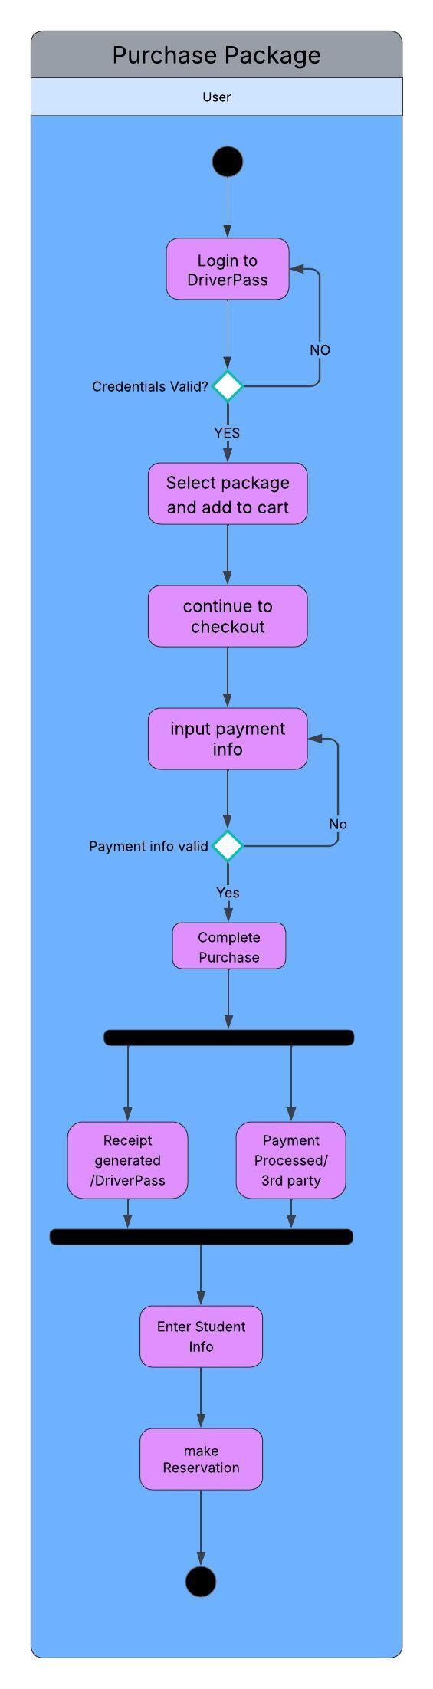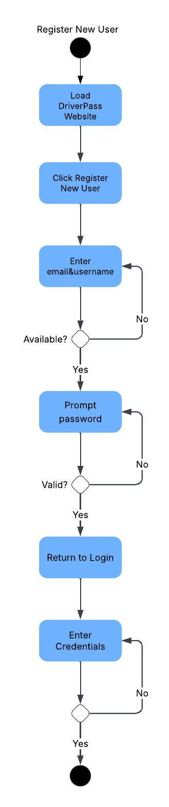

UML Sequence Diagram
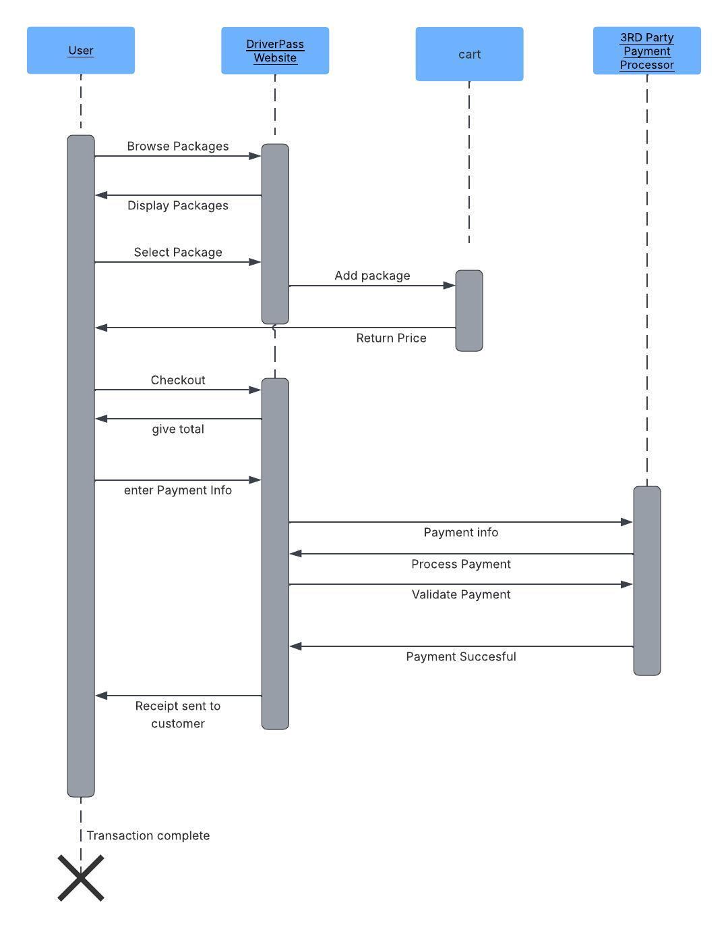

UML Class Diagram
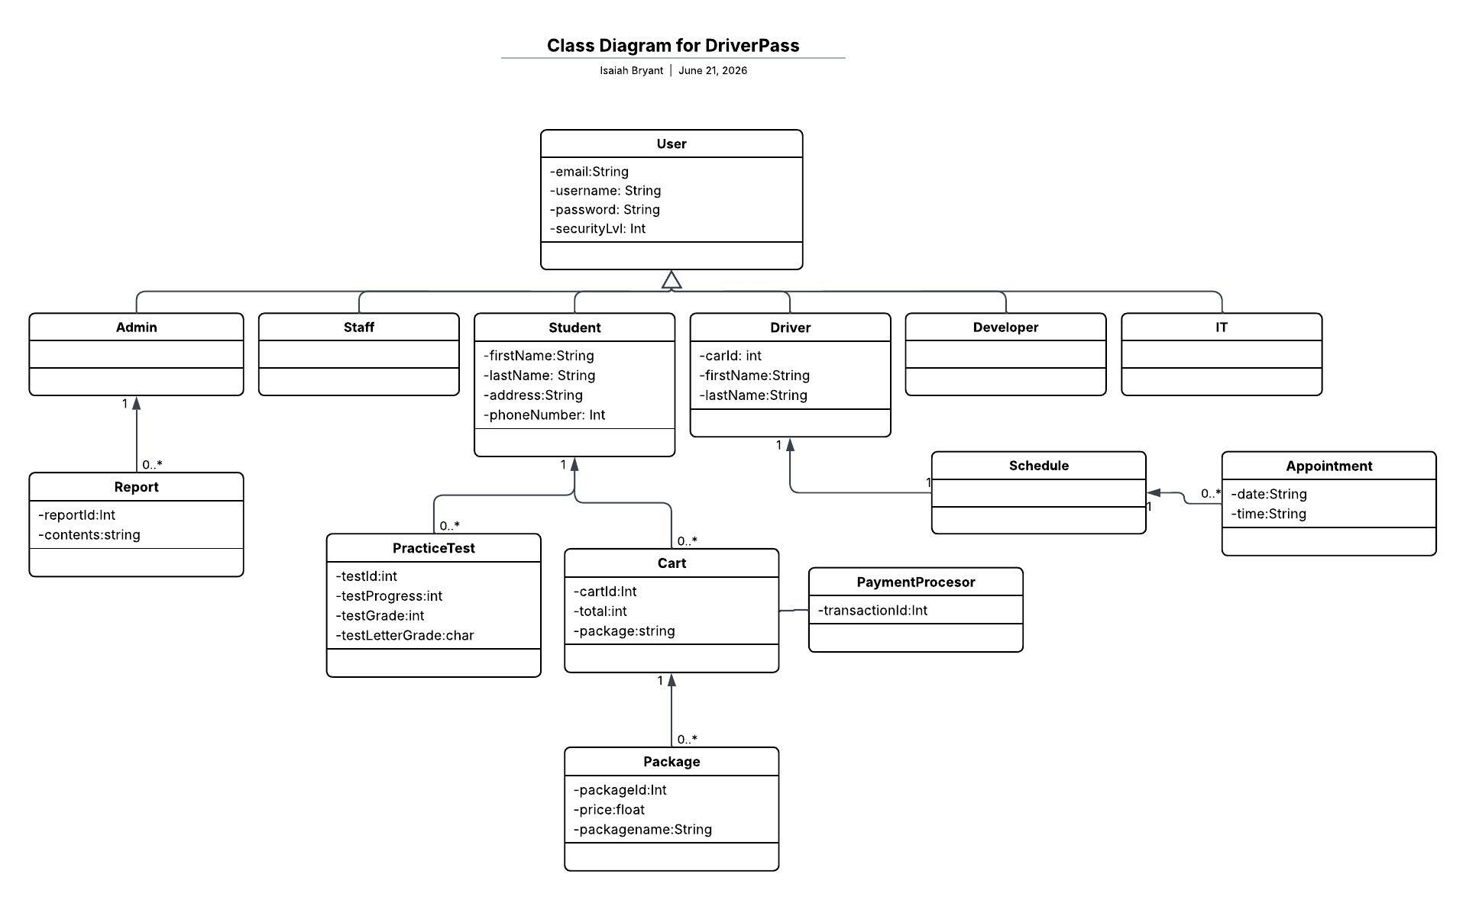

Technical Requirements
The DriverPass system will be a web based cloud hosted application that users can access through any browser on their computer or mobile platforms. The users will be required to maintain an internet connection to make changes, register or purchase packages. The students will be able to access lessons offline. Cloud hosting for the website and user database minimizes overhead for hardware and security. All data will be encrypted using HTTPS during transmission, the cloud host will provide the rest. The system will also use RBAC role based access control to limit users to their authorized actions. Cloud based infrastructure will allow for scalability enabling the DriverPass application to host many users and support the applications functionality. The security for the payment infrastructure will be handled by the third party processor.

